### SYNOPSIS

**Title**

**“Smart Canteen”**

### MCA113-MINI PROJECT

By

“Piyush Kulbhushan Adake”

“3123015010194”

# Mini Project work carried out at

## Faculty of Commerce and Management



**VISHWAKARMA UNIVERSITY**

**PUNE**

September 2023

Project progress Summary:

|  |  |  |  |  |
| --- | --- | --- | --- | --- |
| Sr. No | Description of Work | Start Date | End Date | Status |
| 1 | Study | 22/09/2023 | 25/009/2023 | Completed |
| 2 | Design | 26/09/2023 | 07/10/2023 | Completed |
| 3 | Development | 10/10/2023 | 10/11/2023 | Completed |
| 4 | Testing | 11/11/2023 | 25/11/2023 | Completed |
| 5 | Documentation | 26/11/2023 | 31/11/2023 | In-Process |

* **Study-**

Studded the Project in depth. Calculate the Require time To build the Project.

This project was undertaken with the objective of enhancing accessibility and convenience for students and staff to order meals, access menus, and manage their accounts seamlessly. Studded the User Requirements as well as Admin Requirements. Studded the How flow is working To build the project. Choose the Required Platform for development. As well as choose Required and Suitable Environment(JAVA ENVIRONMENT) For Project.

* **Design-**

The architectural design of the Smart Canteen Website, developed primarily in Java, focused on a layered approach to ensure scalability, maintainability, and extensibility. The system comprised three main layers: the presentation layer, business logic layer, and data access layer. The presentation layer, built using JavaServer Pages (JSP) and Servlets, facilitated the user interface and interaction with end-users.

**Draw the Design for Better Understanding.**

**Draw the Data Flow Diagrams.**

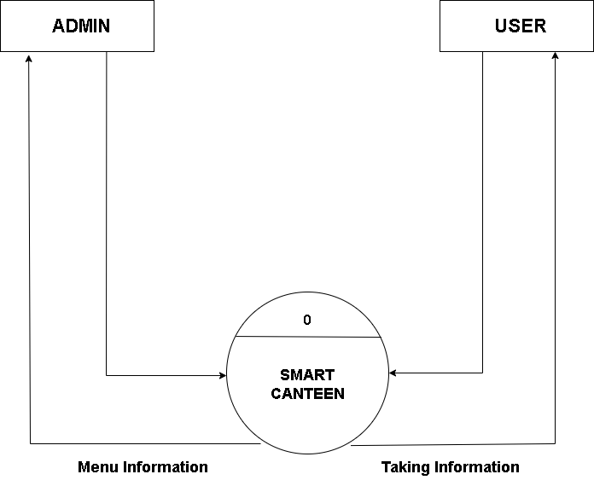

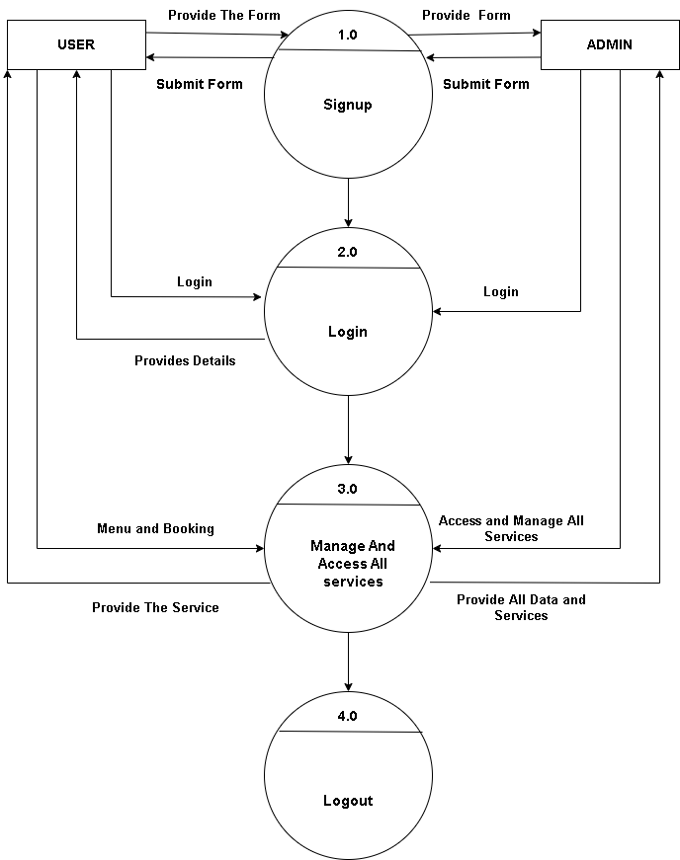

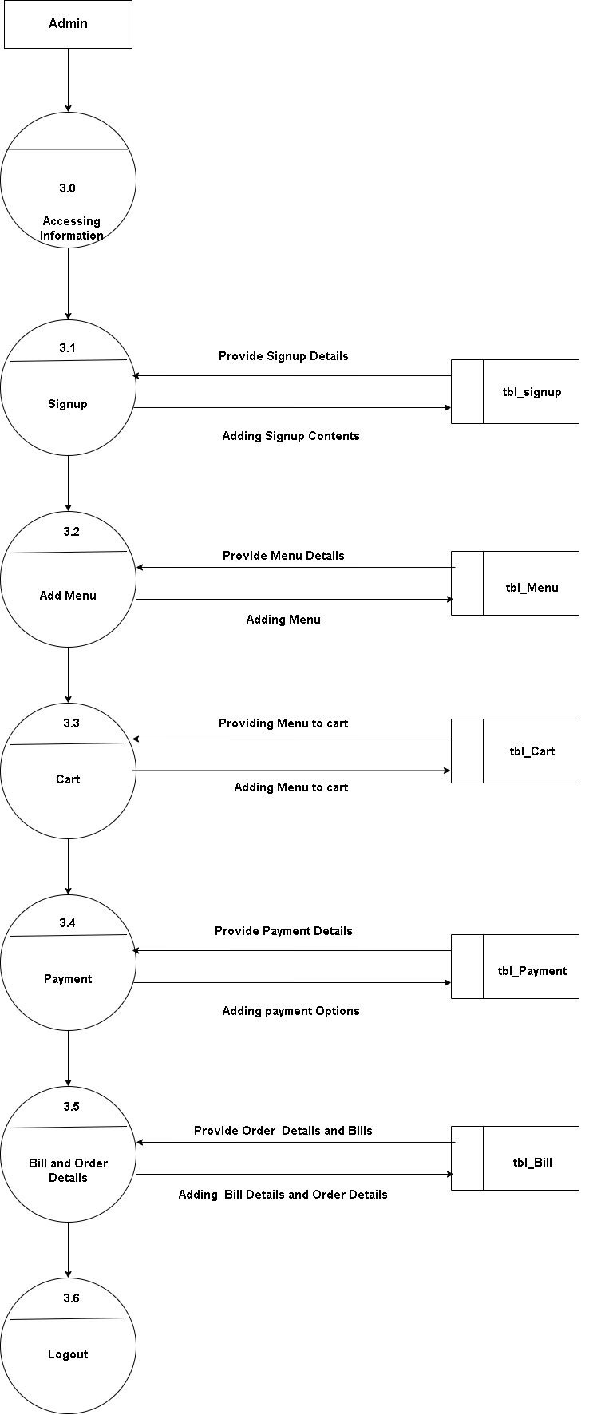

**Draw the Entity Relationship Diagram.**

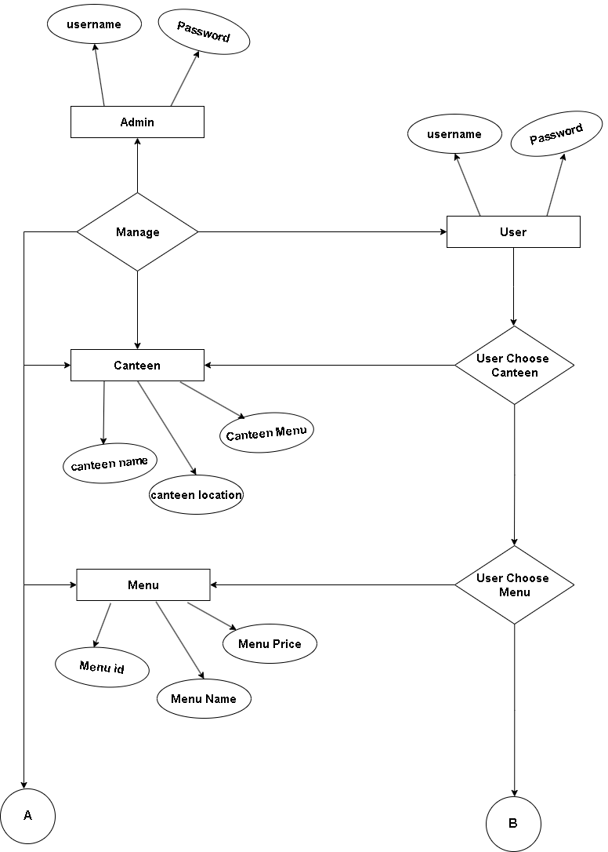

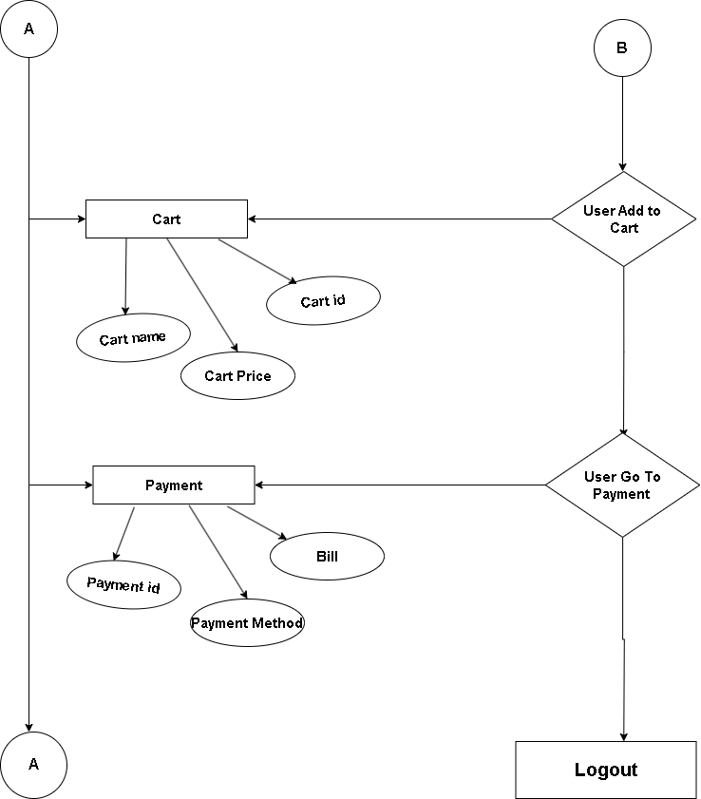

**Draw the Sample of Database Design for Better Understanding of Database Design. And flow of Database.**

**1. Customers:** Information about the customers who visit the canteen.

**2. Menu Items:** Details about the food and beverages available in the canteen.

**3. Orders:** Information about the orders placed by customers.

**4. Employees:** Details about the canteen staff, such as chefs, waiters, etc.

**5. Suppliers:** Information about the suppliers who provide ingredients and other supplies to the canteen.

**6. Transactions:** Records of financial transactions, such as payments and invoices.

* Customers (customer_id, name, contact_info, loyalty_points, ...)
* Menu_Items (item_id, name, description, price, ingredients, ...)
* Orders (order_id, customer_id, order_date, total_amount, ...)
* Employees (employee_id, name, position, contact_info, shift_details, ...)
* Suppliers (supplier_id, name, contact_info, delivery_schedule, ...)
* Transactions (transaction_id, order_id, payment_method, amount, ...)

**Class Diagram-**

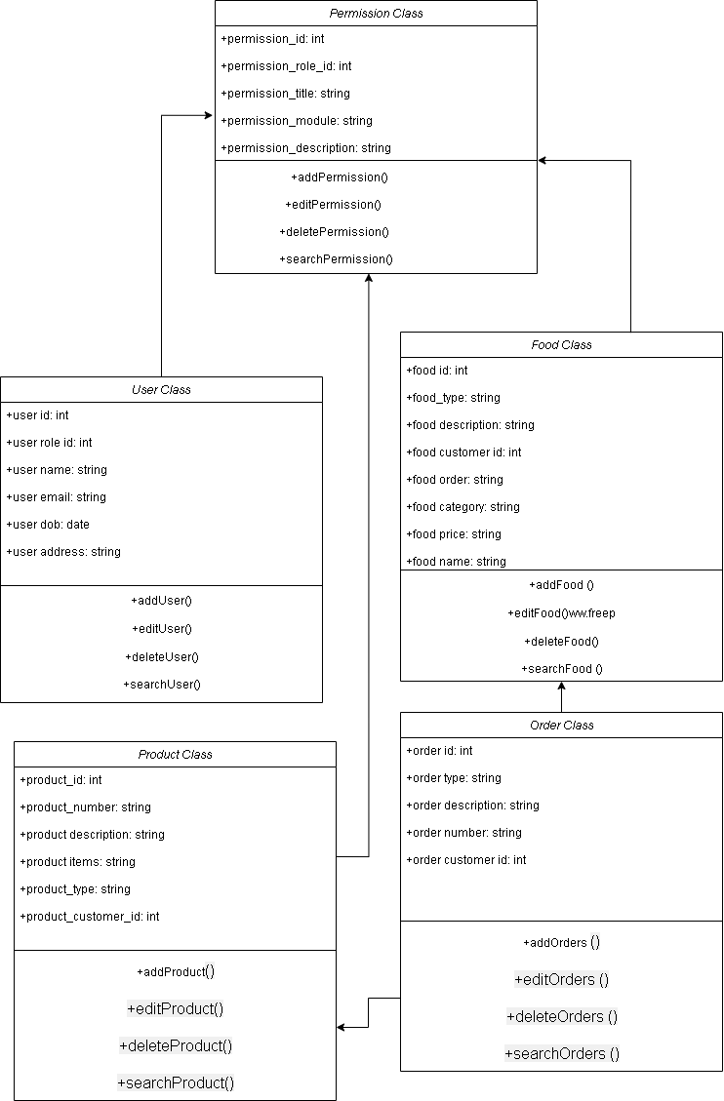

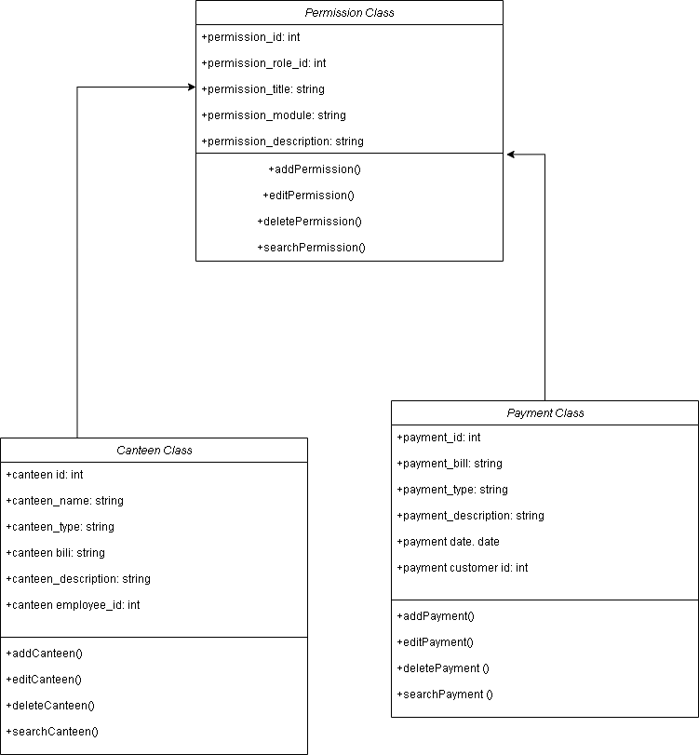

* **Development-**

**Technology Stack**:

* Choose suitable technologies for development, such as Java for back-end logic, HTML/CSS/JavaScript for front-end, and frameworks like Bootstrap for Java-based web applications.
* Select a database system like MySQL to store data.

**Implementation**:

* Develop the front-end using HTML, CSS, JavaScript, and possibly front-end frameworks like Bootstrap to create an interactive UI.
* Implement the back-end logic using Java and frameworks like java Servlet to handle user authentication, menu management, order processing, etc.
* Integrate the front-end and back-end components to ensure seamless communication between them.

**Database Development**:

* Set up the chosen database system.
* Create database tables based on the defined schemas.
* Implement database connectivity in the Java application using JDBC

In Development Phase I Develop .Jsp Pages using Html Bootstrap.

**Index.jsp Page Code-**

<!doctype html>

<html lang="en">

<head>

<meta charset="utf-8">

<meta name="viewport" content="width=device-width, initial-scale=1, shrink-to-fit=no">

<meta name="author" content="Untree.co">

<link rel="shortcut icon" href="favicon.png">

<meta name="description" content="" />

<meta name="keywords" content="bootstrap, bootstrap4" />

<!-- Bootstrap CSS -->

<link href="css/bootstrap.min.css" rel="stylesheet">

<link href="https://cdnjs.cloudflare.com/ajax/libs/font-awesome/6.0.0-beta3/css/all.min.css" rel="stylesheet">

<link href="css/tiny-slider.css" rel="stylesheet">

<link href="css/style.css" rel="stylesheet">

<title>Smart Canteen</title>

<style>

.hero-img-wrap img {

padding-left: 220px;

padding-top: 10px;

width: auto;

height: 550px;

}

.img-wrap{

padding-top: 20px;

}

.sofa-img{

padding-top: 50px;

}

</style>

</head>

<body>

<!-- Start Header/Navigation -->

<nav class="custom-navbar navbar navbar navbar-expand-md navbar-dark bg-dark" arial-label="Furni navigation bar">

<div class="container">

<a class="navbar-brand" href="index.html">Smart Canteen<span>.</span></a>

<button class="navbar-toggler" type="button" data-bs-toggle="collapse" data-bs-target="#navbarsFurni" aria-controls="navbarsFurni" aria-expanded="false" aria-label="Toggle navigation">

<span class="navbar-toggler-icon"></span>

</button>

<div class="collapse navbar-collapse" id="navbarsFurni">

<ul class="custom-navbar-nav navbar-nav ms-auto mb-2 mb-md-0">

<li class="nav-item active">

<a class="nav-link" href="index.jsp">Home</a>

</li>

<li><a class="nav-link" href="shop.html">Shop</a></li>

<li><a class="nav-link" href="about.html">About us</a></li>

<li><a class="nav-link" href="user_login.jsp">Login</a></li>

<li><a class="nav-link" href="contact.html">Feedback</a></li>

</ul>

<ul class="custom-navbar-cta navbar-nav mb-2 mb-md-0 ms-5">

<li><a class="nav-link" href="#"><img src="images/user.svg"></a></li>

<li><a class="nav-link" href="cart.html"><img src="images/cart.svg"></a></li>

</ul>

</div>

</div>

</nav>

<!-- End Header/Navigation -->

<!-- Start Hero Section -->

<div class="hero">

<div class="container">

<div class="row justify-content-between">

<div class="col-lg-5">

<div class="intro-excerpt">

<h1>One Bite at a Time.</h1>

<p class="mb-4">Feeding Your Hunger for Flavors, One Bite at a Time.</p>

<p><a href="" class="btn btn-secondary me-2">Order Now</a><a href="#" class="btn btn-white-outline">Explore</a></p>

</div>

</div>

<div class="col-lg-7">

<div class="hero-img-wrap" class="img-fluid" data-aos="zoom-in" data-aos-delay="200">

<img src="images/bowl-3.png">

</div>

</div>

</div>

</div>

</div>

<!-- End Hero Section -->

<!-- Start Product Section -->

<!-- End Product Section -->

<!-- Start Why Choose Us Section -->

<div class="why-choose-section">

<div class="container">

<div class="row justify-content-between">

<div class="col-lg-5">

<div class="img-wrap">

<img src="images/canteen2.png" alt="Image" class="img-thumbnail" >

</div>

</div>

<div class="col-lg-6">

<h2 class="section-title">Why Choose Us</h2>

<p>Lets Talk About Why Choose Us !</p>

<div class="row my-5">

<div class="col-6 col-md-6">

<div class="feature">

<div class="icon">

<img src="images/truck.svg" alt="Image" class="imf-fluid">

</div>

<h3>Fast &amp; Free Shipping</h3>

<p>We prepare All orders Fast as we can!</p>

</div>

</div>

<div class="col-6 col-md-6">

<div class="feature">

<div class="icon">

<img src="images/bag.svg" alt="Image" class="imf-fluid">

</div>

<h3>Easy to Shop</h3>

<p>One Click for order</p>

</div>

</div>

<div class="col-6 col-md-6">

<div class="feature">

<div class="icon">

<img src="images/support.svg" alt="Image" class="imf-fluid">

</div>

<h3>24/7 Support</h3>

<p>We Read Your Reviews And Queries Any Time !</p>

</div>

</div>

<div class="col-6 col-md-6">

<div class="feature">

<div class="icon">

<img src="images/return.svg" alt="Image" class="imf-fluid">

</div>

<h3>Hassle Free Pickup</h3>

<p>We Have Separate Section For Online Orders </p>

</div>

</div>

</div>

</div>

</div>

</div>

</div>

<!-- End Why Choose Us Section -->

<!-- Start Footer Section -->

<footer class="footer-section">

<div class="container relative">

<div class="sofa-img">

<img src="images/canteen11.png" alt="Image" class="rounded mx-auto d-block">

</div>

<div class="row g-5 mb-5">

<div class="col-lg-4">

<div class="mb-4 footer-logo-wrap"><a href="#" class="footer-logo">Smart Canteen<span>.</span></a></div>

<p class="mb-4">Feeding Your Hunger for Flavors, One Bite at a Time.</p>

</div>

<div class="col-lg-8">

<div class="row links-wrap">

<div class="col-md-6">

<ul class="list-unstyled">

<li style="display: inline-block;"><a class="nav-link" href="shop.html">Shop</a></li>

<li style="display: inline-block;"><a class="nav-link" href="about.html">About us</a></li>

<li style="display: inline-block;"><a class="nav-link" href="user_login.jsp">Login</a></li>

<li style="display: inline-block;"><a class="nav-link" href="contact.html">Feedback</a></li>

</ul>

</div>

</div>

</div>

</div>

<div class="border-top copyright">

<div class="row pt-4">

<div class="col-lg-6">

<p class="mb-2 text-center text-lg-start">Copyright &copy;<script>document.write(new Date().getFullYear());</script>. All Rights Reserved. &mdash; Designed with love by <a href="https://piyushadake.000webhostapp.com/">PiyushAdake</a>

</p>

</div>

</div>

</div>

</div>

</footer>

<!-- End Footer Section -->

<script src="js/bootstrap.bundle.min.js"></script>

<script src="js/tiny-slider.js"></script>

<script src="js/custom.js"></script>

</body>

</html>

This Is Starting Page Of Smart Canteen Which Basically Shows The Actual Information .

**Add_Menu.java page Code-**

import java.io.IOException;

import java.io.PrintWriter;

import javax.servlet.ServletException;

import javax.servlet.http.HttpServlet;

import javax.servlet.http.HttpServletRequest;

import javax.servlet.http.HttpServletResponse;

public class Add_Menu extends HttpServlet {

@Override

protected void doPost(HttpServletRequest req, HttpServletResponse resp) throws ServletException, IOException {

PrintWriter out = resp.getWriter();

String menu_id=req.getParameter("menu_id");

String menu_name=req.getParameter("menu_name");

String menu_price=req.getParameter("menu_price");

String menu_img=req.getParameter("menu_img");

String menu_description=req.getParameter("menu_description");

String event=req.getParameter("btn_save");

out.println(menu_name);

out.println(menu_price);

out.println(menu_img);

out.println(menu_description);

out.println(event);

DatabaseConnection db = new DatabaseConnection();

out.println(db.Connectdb());

if(event.equals("btn_save"))

{

String query1 = "insert into tbl_menu(menu_name,menu_price,menu_img,menu_description)values('"+menu_name+"','"+menu_price+"','Img/"+menu_img+"','"+menu_description+"')";

String result = db.Query(query1, "Menu Inserted");

out.println(result);

if(event.equals("Update"))

{

query1 = db.Query("Update tbl_menu set menu_name='" +menu_name+ "', menu_price='" +menu_price+ "',menu_img='Img/" +menu_img+ "', menu_description='" +menu_description+ "'WHERE menu_id='" +menu_id+ "'", "Record Updated");

result = db.Query(query1, "Menu Updated");

out.println(result);

}

resp.setContentType("text/html;charset=UTF-8");

out.println("<script>");

out.println("alert('Menu Added successful');");

//out.println("window.location='Admin_Signup.jsp';");

out.println("</script>");

}

}

// Other overridden methods remain unchanged

}

This Page Adding Menu Details in the Database. Its Contain Menu_Id, Menu_name, Menu_Price, Menu_Description, Etc..

**View_Employee.jsp Page Code-**

<%@page import="java.sql.Connection"%>

<%@page import="java.sql.ResultSet"%>

<%@page import="java.sql.DriverManager"%>

<%@page import="java.sql.Statement"%>

<!DOCTYPE html>

<html lang="en">

<head>

<style>

* {

box-sizing: border-box;

}

#myTable {

border-collapse: collapse;

width: 100%;

border: 1px solid #ddd;

font-size: 16px;

}

#myTable th, #myTable td {

text-align: left;

padding: 4px;

}

#myTable tr {

border-bottom: 1px solid #ddd;

}

#myTable tr.header, #myTable tr:hover {

background-color: #f1f1f1;

}

</style>

<meta charset="utf-8">

<meta content="width=device-width, initial-scale=1.0" name="viewport">

<title>View Employee</title>

<meta content="" name="description">

<meta content="" name="keywords">

<!-- Favicons -->

<link href="assets/img/Logo Smart.png" rel="icon">

<link href="assets/img/apple-touch-icon.png" rel="apple-touch-icon">

<!-- Google Fonts -->

<link href="https://fonts.gstatic.com" rel="preconnect">

<link href="https://fonts.googleapis.com/css?family=Open+Sans:300,300i,400,400i,600,600i,700,700i|Nunito:300,300i,400,400i,600,600i,700,700i|Poppins:300,300i,400,400i,500,500i,600,600i,700,700i" rel="stylesheet">

<!-- Vendor CSS Files -->

<link href="assets/vendor/bootstrap/css/bootstrap.min.css" rel="stylesheet">

<link href="assets/vendor/bootstrap-icons/bootstrap-icons.css" rel="stylesheet">

<link href="assets/vendor/boxicons/css/boxicons.min.css" rel="stylesheet">

<link href="assets/vendor/quill/quill.snow.css" rel="stylesheet">

<link href="assets/vendor/quill/quill.bubble.css" rel="stylesheet">

<link href="assets/vendor/remixicon/remixicon.css" rel="stylesheet">

<link href="assets/vendor/simple-datatables/style.css" rel="stylesheet">

<!-- Template Main CSS File -->

<link href="assets/css/style.css" rel="stylesheet">

</head>

<body>

<!-- ======= Header ======= -->

<header id="header" class="header fixed-top d-flex align-items-center">

<div class="d-flex align-items-center justify-content-between">

<a href="index.html" class="logo d-flex align-items-center">

<img src="assets/img/Logo Smart.png" alt="">

<span class="d-none d-lg-block">Smart Canteen</span>

</a>

<i class="bi bi-list toggle-sidebar-btn"></i>

</div><!-- End Logo -->

<!-- End Icons Navigation -->

</header><!-- End Header -->

<!-- ======= Sidebar ======= -->

<aside id="sidebar" class="sidebar">

<ul class="sidebar-nav" id="sidebar-nav">

<!--List Pages Starts Heres -->

<li class="nav-item">

<a class="nav-link " href="admin_dashbord.jsp">

<i class="bi bi-grid"></i>

<span>Dashboard</span>

</a>

</li>

<li class="nav-item">

<a class="nav-link " href="Add_Menu.jsp">

<i class="bi bi-bag"></i>

<span>Add Menu</span>

</a>

</li>

<li class="nav-item">

<a class="nav-link " href="view_menu.jsp">

<i class="bi bi-card-list"></i>

<span>View Menu</span>

</a>

</li>

<li class="nav-item">

<a class="nav-link " href="admin_completedorders.jsp">

<i class="bi bi-bag-check-fill"></i>

<span>Completed Orders</span>

</a>

</li>

<li class="nav-item">

<a class="nav-link " href="admin_cancelledorders.jsp">

<i class="bi bi-cart-x-fill"></i>

<span>Cancelled Orders</span>

</a>

</li>

<br>

<br>

<li class="nav-item">

<a class="nav-link " href="Add_Emp.jsp">

<i class="ri-group-fill"></i>

<span>Add Employee</span>

</a>

</li>

<li class="nav-item">

<a class="nav-link " href="Employee_Attendance.jsp">

<i class="bi bi-card-list"></i>

<span>Employee Attendance </span>

</a>

</li>

<li class="nav-item">

<a class="nav-link " href="View_Employees.jsp">

<i class="bi bi-person-lines-fill"></i>

<span>View Employee</span>

</a>

</li>

<!-- End Tables Nav -->

<li class="nav-item">

<a class="nav-link " href="View_Feedback.jsp">

<i class="bi bi-envelope"></i>

<span>View FeedBack</span>

</a>

</li><!-- End Feedback Page Nav -->

<br>

<!-- End Register Page Nav -->

<li class="nav-item">

<a class="nav-link" href="admin_Login.jsp">

<i class="bi bi-box-arrow-in-right"></i>

<span>Logout</span>

</a>

</li><!-- End Login Page Nav -->

</ul>

</aside><!-- End Sidebar-->

<!-- Main Card-->

<main id="main" class="main">

<form action="update_emp" method="POST">

<div class="col-12">

<div class="card recent-sales overflow-auto">

<div class="card-body">

<h5 class="card-title">View Employee</h5>

<table id="myTable">

<tr>

<th scope="col">#</th>

<th>Employee Name</th>

<th>Phone Number</th>

<th>Address</th>

<th>Profile Img</th>

<th>Proof Document</th>

<th>Action</th>

</tr>

<% int counter = 1;

Connection cn = null;

Statement st = null;

try {

Class.forName("com.mysql.jdbc.Driver");

cn = DriverManager.getConnection("jdbc:mysql://localhost:3306/smart_canteen", "root", "root");

st = cn.createStatement();

String sql = "select * from tbl_emp";

ResultSet rs = st.executeQuery(sql);

while (rs.next()) {

String emp_id = rs.getString("emp_id");

%>

<form action="update_emp" method="POST">

<tbody>

<tr>

<input type="hidden" name="emp_id" value="<%= emp_id %>">

<th scope="row"><%= counter++ %></th>

<td><input type="text" class="form-control" name="emp_name" value="<%= rs.getString("emp_name") %>"></td>

<td><input type="text" class="form-control" name="emp_no" value="<%= rs.getString("emp_no") %>"></td>

<td><input type="text" class="form-control" name="emp_address" value="<%= rs.getString("emp_address") %>"></td>

<td><input type="file" class="custom-file-input" id="" name="emp_profile"></td>

<td><input type="file" class="custom-file-input" id="" name="emp_proof"></td>

<td>

<button type="submit" class="btn btn-primary" name="btn_save" value="Update">Update</button>

<button type="submit" class="btn btn-warning" name="btn_save" value="Delete">Delete</button>

</td>

</tr>

</tbody>

</form>

<% }

// Close database connections and handle exceptions

} catch (Exception ex) {

out.println(ex.toString());

} %>

</table>

<script>

function myFunction() {

var input, filter, table, tr, td, i, txtValue;

input = document.getElementById("myInput");

filter = input.value.toUpperCase();

table = document.getElementById("myTable");

tr = table.getElementsByTagName("tr");

for (i = 0; i < tr.length; i++) {

td = tr[i].getElementsByTagName("td")[0];

if (td) {

txtValue = td.textContent || td.innerText;

if (txtValue.toUpperCase().indexOf(filter) > -1) {

tr[i].style.display = "";

} else {

tr[i].style.display = "none";

}

}

}

}

</script>

</div>

</div>

</div>

</form>

</main>

<!-- Main Card End-->

<a href="#" class="back-to-top d-flex align-items-center justify-content-center"><i class="bi bi-arrow-up-short"></i></a>

<!-- Vendor JS Files -->

<script src="assets/vendor/apexcharts/apexcharts.min.js"></script>

<script src="assets/vendor/bootstrap/js/bootstrap.bundle.min.js"></script>

<script src="assets/vendor/chart.js/chart.umd.js"></script>

<script src="assets/vendor/echarts/echarts.min.js"></script>

<script src="assets/vendor/quill/quill.min.js"></script>

<script src="assets/vendor/simple-datatables/simple-datatables.js"></script>

<script src="assets/vendor/tinymce/tinymce.min.js"></script>

<script src="assets/vendor/php-email-form/validate.js"></script>

<!-- Template Main JS File -->

<script src="assets/js/main.js"></script>

</body>

</html>

This Page Contains Added Employee Details. Which Shows Details From The Database. Its Also Update and Delete Employee Details.

**Add_Employee.java Page Code-**

import java.io.IOException;

import java.io.PrintWriter;

import javax.servlet.ServletException;

import javax.servlet.http.HttpServlet;

import javax.servlet.http.HttpServletRequest;

import javax.servlet.http.HttpServletResponse;

public class add_emp extends HttpServlet {

@Override

protected void doPost(HttpServletRequest req, HttpServletResponse resp) throws ServletException, IOException {

PrintWriter out = resp.getWriter();

String emp_id=req.getParameter("emp_id");

String emp_name=req.getParameter("emp_name");

String emp_no=req.getParameter("emp_no");

String emp_profile=req.getParameter("emp_profile");

String emp_proof=req.getParameter("emp_proof");

String emp_address=req.getParameter("emp_address");

String event=req.getParameter("btn_save");

out.println(emp_name);

out.println(emp_no);

out.println(emp_profile);

out.println(emp_proof);

out.println(emp_address);

out.println(event);

DatabaseConnection db = new DatabaseConnection();

out.println(db.Connectdb());

if(event.equals("btn_save"))

{

String query1 = "insert into tbl_emp(emp_name,emp_no,emp_profile,emp_proof,emp_address)values('"+emp_name+"','"+emp_no+"','Img/"+emp_profile+"','Img/"+emp_proof+"','"+emp_address+"')";

String result = db.Query(query1, "Employee Inserted");

out.println(result);

if(event.equals("Update"))

{

String query1 = "Update tbl_emp set emp_name='" +emp_name+ "', emp_no='" +emp_no+ "',emp_profile='Img/" +emp_profile+ "', emp_proof='Img/" +emp_proof+ "', emp_address='" +emp_address+ "'WHERE emp_id='" +emp_id+ "'";

String result = db.Query(query1, "Record Updated");

out.println(result);

}

else if (event.equals("Delete")) {

String deleteQuery = "DELETE FROM tbl_emp WHERE emp_id='" + emp_id + "'";

String result = db.Query(deleteQuery, "Record Deleted");

out.println(result);

}

resp.setContentType("text/html;charset=UTF-8");

out.println("<script>");

out.println("alert('employee Added successful');");

out.println("window.location='View_Employees.jsp';");

out.println("</script>");

}

}

// Other overridden methods remain unchanged

}

This Is java Servlet Page Which Responsible For Adding Employee Details In Database. Which Contain Emp_Id, Emp_name, Emp_Phone, Emp_Profile, Etc.

This Page Also Update and Delete Employee Details from The database.

* **Testing-**

**Unit Testing-**

Unit testing for a Java web application such as a smart canteen system involves the systematic testing of individual code units, like classes or methods, in isolation to validate their functionality. Employing frameworks like JUnit or TestNG facilitates the creation and execution of these tests. To ensure comprehensive coverage, aim for high test coverage, encompassing various scenarios, including edge cases and expected inputs. Employing mocking frameworks like Mockito or EasyMock is beneficial, allowing the creation of mock objects for dependencies, thereby isolating the code under test and facilitating controlled behavior for diverse scenarios. When structuring tests, organizing them logically by package or module aids in maintaining a structured testing suite.

**Integration Testing-**

Integration tests verify the collaboration and integration of various modules or services within the smart canteen system. Utilizing frameworks like JUnit or TestNG can aid in writing and executing integration tests that cover interconnected functionalities, ensuring their proper coordination. These tests focus on assessing how different components, such as the menu management system, order processing, payment handling, and user authentication, interact and function together.

**Sample Screens-**

**Fig1-Home.jsp**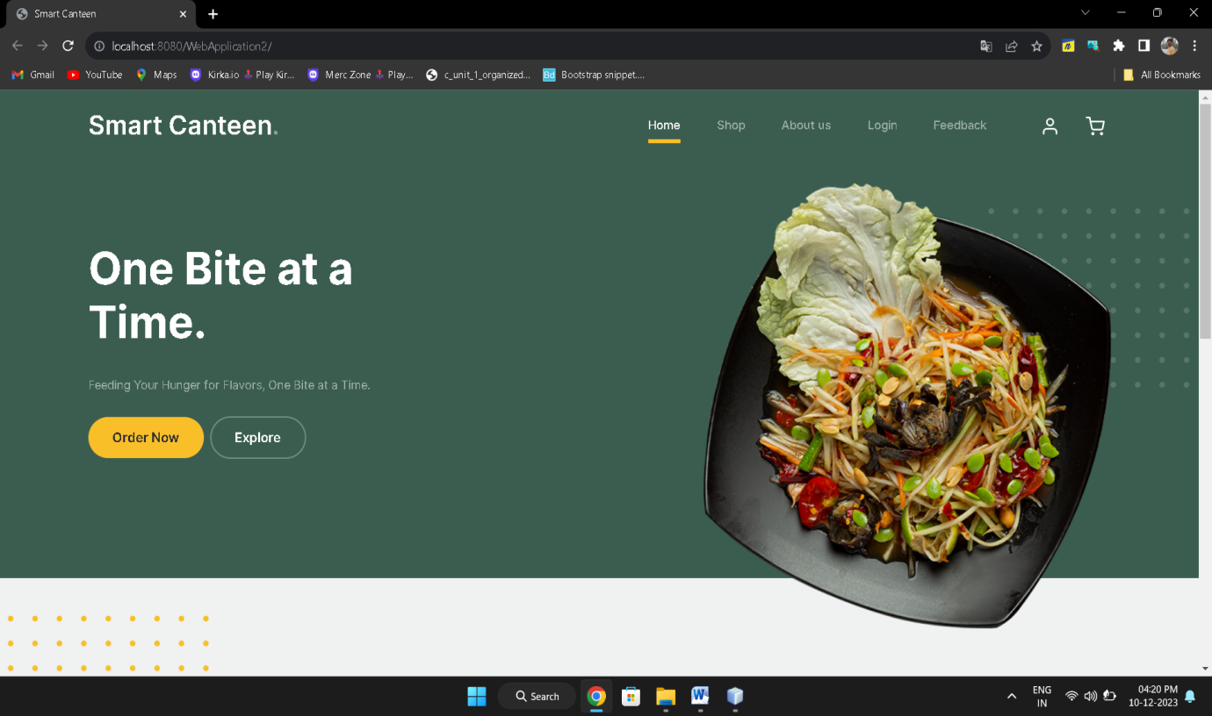

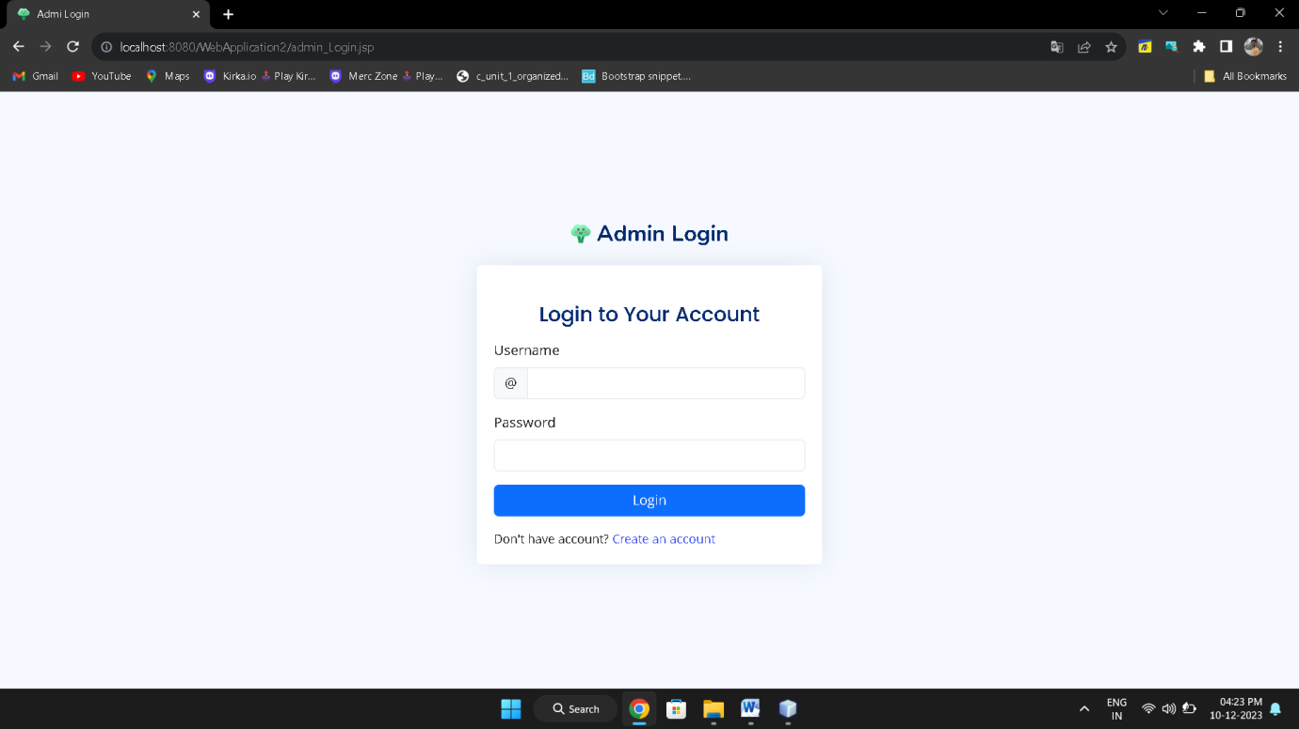

**Fig2-Admin_login.jsp**

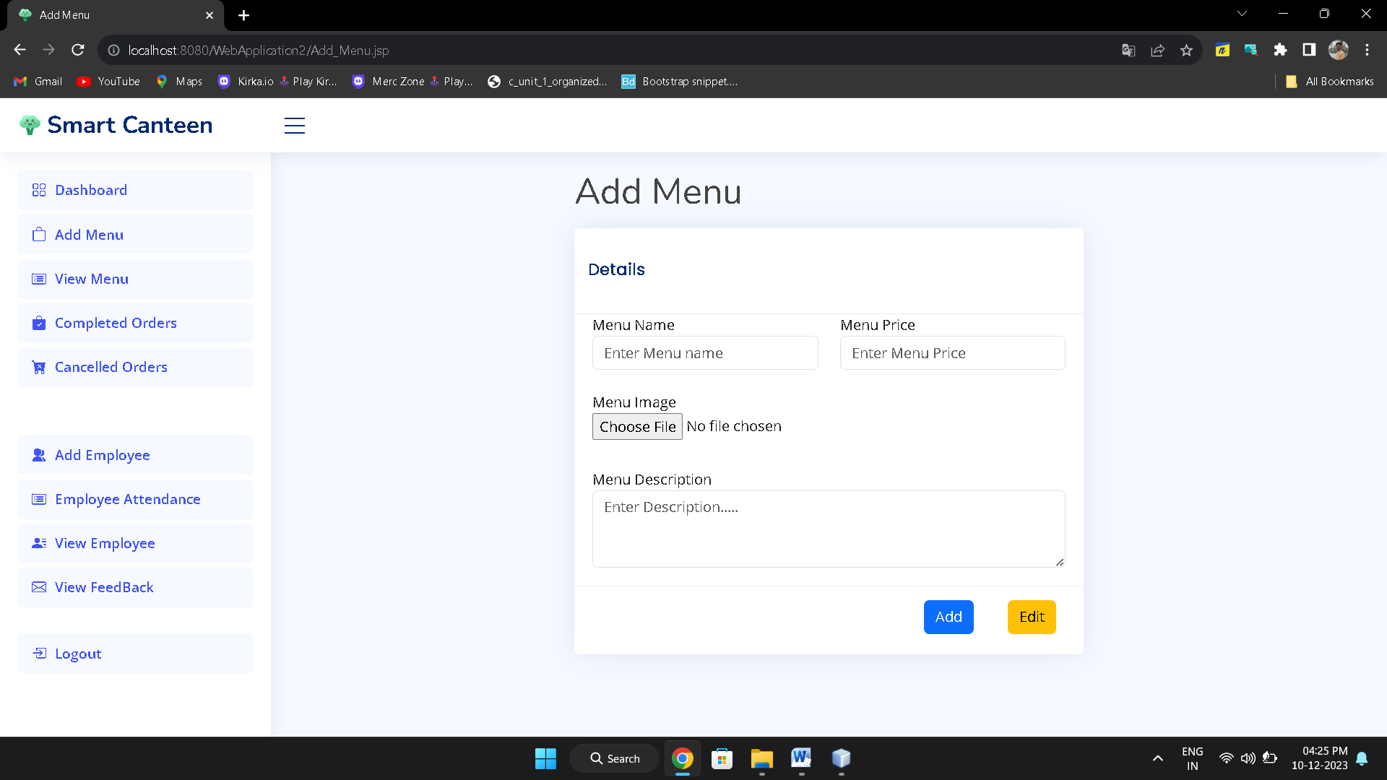

**Fig3-Add_menu.jsp**

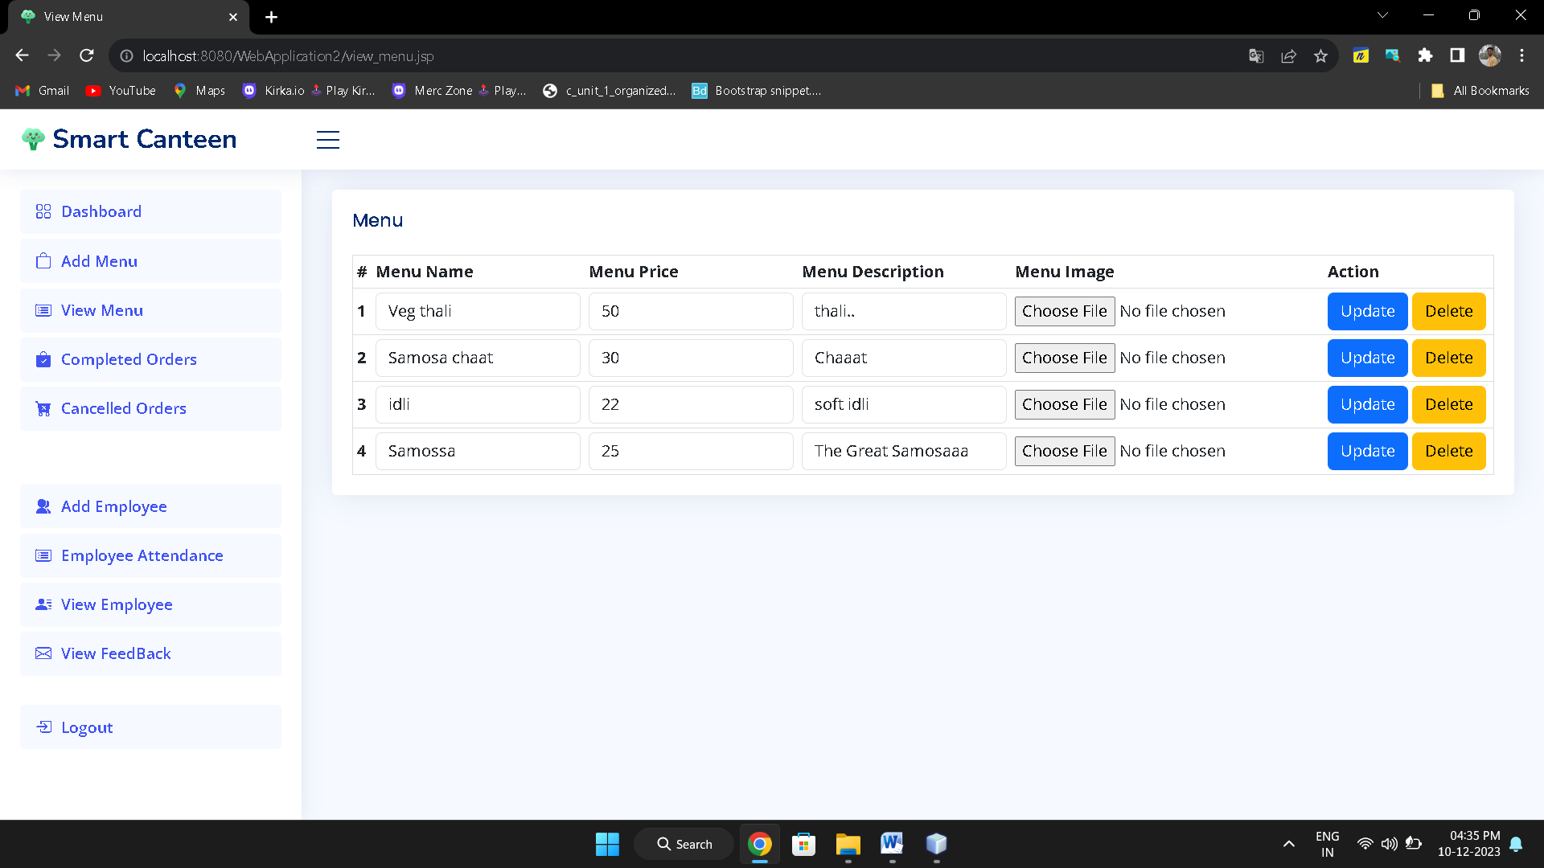

**Fig4-View_Menu.jsp**

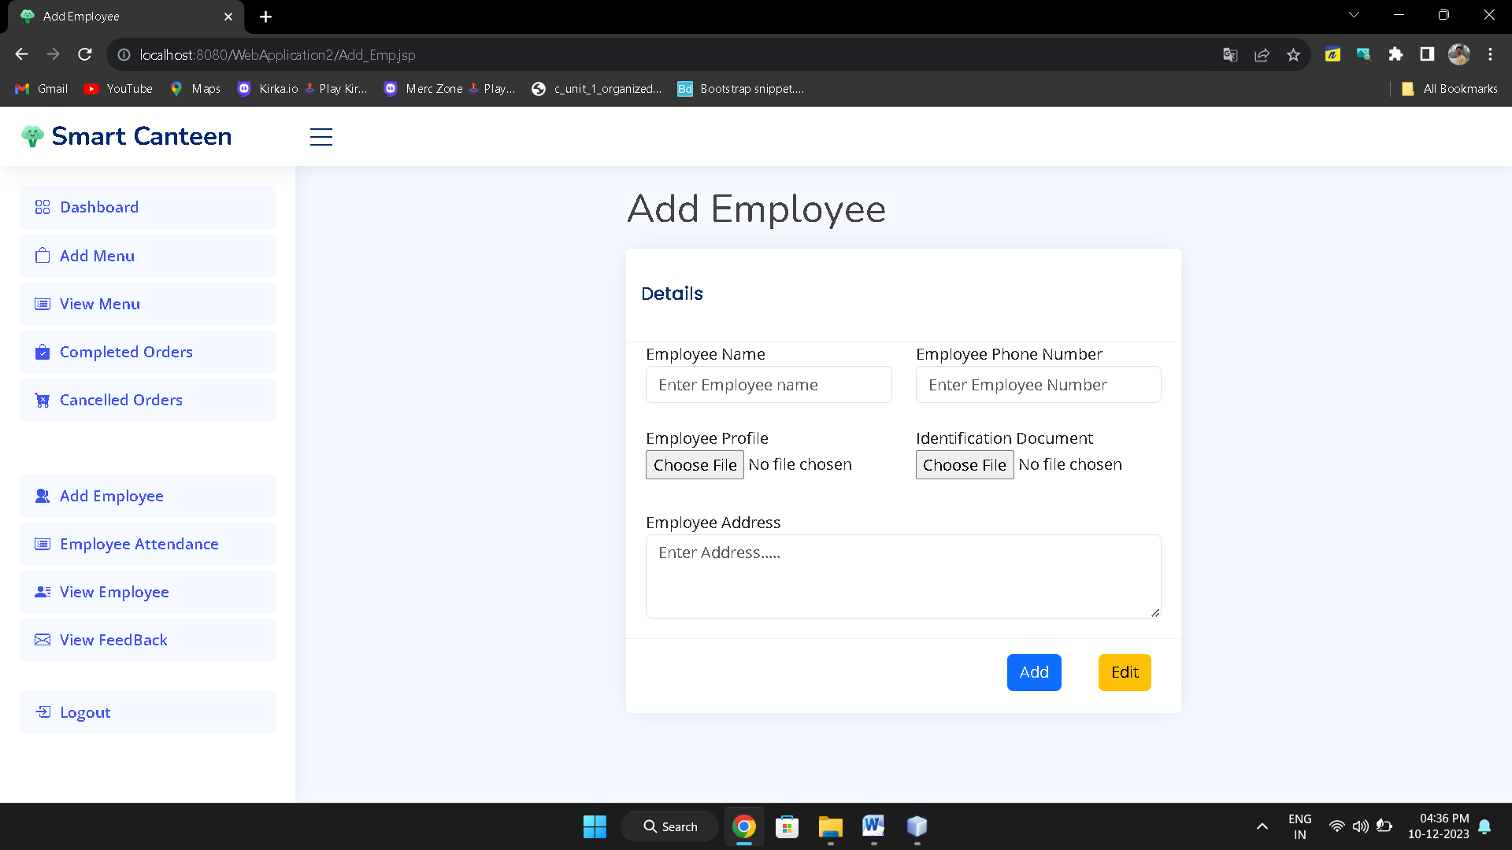

**Fig5-Add_Employee.jsp**

* **Documentation -**

The Documentation Phase is In-Process .